PHASE V: DATA IMPLEMENTATION AND DATA INSERTION

CREATING TABLES

-- CLIENTS
CREATE TABLE Clients (
client_id NUMBER GENERATED BY DEFAULT AS IDENTITY PRIMARY KEY,
name VARCHAR2(100) NOT NULL UNIQUE,
industry VARCHAR2(100),
contact_info VARCHAR2(150),
service_type VARCHAR2(20) CHECK (service_type IN ('architecture', 'branding', 'both'))
);

-- TEAM MEMBERS
CREATE TABLE TeamMembers (
member_id NUMBER GENERATED BY DEFAULT AS IDENTITY PRIMARY KEY,
name VARCHAR2(100) NOT NULL,
role VARCHAR2(50) NOT NULL,
email VARCHAR2(100) UNIQUE,
phone VARCHAR2(20)
);

-- PROJECTS
CREATE TABLE Projects (
project_id NUMBER GENERATED BY DEFAULT AS IDENTITY PRIMARY KEY,
client_id NUMBER NOT NULL,
title VARCHAR2(150) NOT NULL,
project_type VARCHAR2(50) CHECK (project_type IN ('Architecture','Branding','Mixed')),
start_date DATE DEFAULT SYSDATE,
end_date DATE,
budget NUMBER(12,2) DEFAULT 0,
status VARCHAR2(30) DEFAULT 'Pending' CHECK (status IN ('Pending','In Progress','Completed','Cancelled')),
CONSTRAINT fk_projects_client FOREIGN KEY (client_id) REFERENCES Clients(client_id) ON DELETE CASCADE
);
CREATE INDEX idx_projects_client ON Projects(client_id);

-- DESIGNS
CREATE TABLE Designs (
design_id NUMBER GENERATED BY DEFAULT AS IDENTITY PRIMARY KEY,
project_id NUMBER NOT NULL,
design_type VARCHAR2(50),
file_path VARCHAR2(255),
created_at DATE DEFAULT SYSDATE,
CONSTRAINT fk_designs_project FOREIGN KEY (project_id) REFERENCES Projects(project_id) ON DELETE CASCADE
);
CREATE INDEX idx_designs_project ON Designs(project_id);

-- PROJECT TEAM
CREATE TABLE ProjectTeam (
project_id NUMBER NOT NULL,
member_id NUMBER NOT NULL,
role_on_project VARCHAR2(50),
CONSTRAINT pk_projectteam PRIMARY KEY (project_id, member_id),
CONSTRAINT fk_projectteam_project FOREIGN KEY (project_id) REFERENCES Projects(project_id) ON DELETE CASCADE,
CONSTRAINT fk_projectteam_member FOREIGN KEY (member_id) REFERENCES TeamMembers(member_id)
);
CREATE INDEX idx_projectteam_project ON ProjectTeam(project_id);
CREATE INDEX idx_projectteam_member ON ProjectTeam(member_id);

-- SALES
CREATE TABLE Sales (
sale_id NUMBER GENERATED BY DEFAULT AS IDENTITY PRIMARY KEY,
project_id NUMBER NOT NULL,
client_id NUMBER NOT NULL,
design_id NUMBER,
amount NUMBER(12,2) NOT NULL CHECK (amount >= 0),
issued_date DATE DEFAULT SYSDATE,
CONSTRAINT fk_sales_project FOREIGN KEY (project_id) REFERENCES Projects(project_id) ON DELETE CASCADE,
CONSTRAINT fk_sales_client FOREIGN KEY (client_id) REFERENCES Clients(client_id),
CONSTRAINT fk_sales_design FOREIGN KEY (design_id) REFERENCES Designs(design_id)
);
CREATE INDEX idx_sales_project ON Sales(project_id);
CREATE INDEX idx_sales_client ON Sales(client_id);
CREATE INDEX idx_sales_design ON Sales(design_id);

INSERTING DATA

-- 1. CLIENTS TABLE –

INSERT INTO Clients (name, industry, contact_info, service_type) VALUES ('MTN Rwanda', 'Telecom', 'info@mtn.rw', 'both');
INSERT INTO Clients (name, industry, contact_info, service_type) VALUES ('RDB', 'Government', 'contact@rdb.rw', 'architecture');
INSERT INTO Clients (name, industry, contact_info, service_type) VALUES ('Bank of Kigali', 'Finance', 'info@bk.rw', 'branding');
INSERT INTO Clients (name, industry, contact_info, service_type) VALUES ('I&M Bank', 'Finance', 'info@imbank.rw', 'both');
INSERT INTO Clients (name, industry, contact_info, service_type) VALUES ('Kigali Heights', 'Real Estate', 'contact@kigaliheights.rw', 'architecture');
INSERT INTO Clients (name, industry, contact_info, service_type) VALUES ('Rwanda Housing Authority', 'Government', 'info@rha.rw', 'architecture');
INSERT INTO Clients (name, industry, contact_info, service_type) VALUES ('Marriott Kigali', 'Hospitality', 'info@marriott.rw', 'branding');
INSERT INTO Clients (name, industry, contact_info, service_type) VALUES ('Bralirwa', 'Beverage', 'info@bralirwa.rw', 'both');
INSERT INTO Clients (name, industry, contact_info, service_type) VALUES ('Rwanda Development Bank', 'Finance', 'contact@rdbank.rw', 'architecture');
INSERT INTO Clients (name, industry, contact_info, service_type) VALUES ('CIMERWA', 'Manufacturing', 'info@cimerwa.rw', 'branding');
COMMIT;

-- 2. TEAM MEMBERS

INSERT INTO TeamMembers (name, role, email, phone) VALUES ('Rugira Noella', 'Architect', 'rugira.noella@gmail.com', '0788123450');
INSERT INTO TeamMembers (name, role, email, phone) VALUES ('Divine Ukwishatse', 'GraphicDesigner', 'divine.ukwishatse@gmail.com', '0788123451');
INSERT INTO TeamMembers (name, role, email, phone) VALUES ('Abumukiza Clement', 'Consultant', 'abumukiza.clement@gmail.com', '0788123452');
INSERT INTO TeamMembers (name, role, email, phone) VALUES ('Yves Ntwali', 'Architect', 'yves.ntwali@gmail.com', '0788123453');
INSERT INTO TeamMembers (name, role, email, phone) VALUES ('Alice Uwimana', 'GraphicDesigner', 'alice.uwimana@gmail.com', '0788123454');
INSERT INTO TeamMembers (name, role, email, phone) VALUES ('Jean Pierre', 'Consultant', 'jean.pierre@gmail.com', '0788123455');
INSERT INTO TeamMembers (name, role, email, phone) VALUES ('Sandrine Mukashema', 'Architect', 'sandrine.mukashema@gmail.com', '0788123456');
INSERT INTO TeamMembers (name, role, email, phone) VALUES ('Eric Nkurunziza', 'GraphicDesigner', NULL, '0788123457');
INSERT INTO TeamMembers (name, role, email, phone) VALUES ('Josiane Uwase', 'Consultant', 'josiane.uwase@gmail.com', NULL);
INSERT INTO TeamMembers (name, role, email, phone) VALUES ('Patrick Habimana', 'Architect', 'patrick.habimana@gmail.com', '0788123459');

COMMIT;

-- 3. PROJECTS

INSERT INTO Projects (client_id, title, project_type, start_date, end_date, budget, status)
VALUES (1, 'MTN HQ Renovation', 'Architecture', TO_DATE('2025-01-01','YYYY-MM-DD'), TO_DATE('2025-12-31','YYYY-MM-DD'), 2500000, 'In Progress');
INSERT INTO Projects (client_id, title, project_type, start_date, end_date, budget, status)
VALUES (2, 'RDB Office Expansion', 'Architecture', TO_DATE('2024-03-01','YYYY-MM-DD'), TO_DATE('2024-09-30','YYYY-MM-DD'), 1200000, 'Completed');
INSERT INTO Projects (client_id, title, project_type, start_date, end_date, budget, status)
VALUES (3, 'Bank of Kigali Branding Campaign', 'Branding', TO_DATE('2025-02-01','YYYY-MM-DD'), TO_DATE('2025-06-30','YYYY-MM-DD'), 500000, 'In Progress');
INSERT INTO Projects (client_id, title, project_type, start_date, end_date, budget, status)
VALUES (4, 'I&M Bank Digital Branding', 'Branding', TO_DATE('2025-01-15','YYYY-MM-DD'), TO_DATE('2025-05-15','YYYY-MM-DD'), 400000, 'Pending');
INSERT INTO Projects (client_id, title, project_type, start_date, end_date, budget, status)
VALUES (5, 'Kigali Heights Interior Design', 'Architecture', TO_DATE('2024-06-01','YYYY-MM-DD'), TO_DATE('2025-01-31','YYYY-MM-DD'), 1500000, 'Completed');
INSERT INTO Projects (client_id, title, project_type, start_date, end_date, budget, status)
VALUES (6, 'Marriott Kigali Branding Refresh', 'Branding', TO_DATE('2025-03-01','YYYY-MM-DD'), TO_DATE('2025-08-31','YYYY-MM-DD'), 600000, 'In Progress');
INSERT INTO Projects (client_id, title, project_type, start_date, end_date, budget, status)
VALUES (7, 'Bralirwa Packaging Redesign', 'Branding', TO_DATE('2025-04-01','YYYY-MM-DD'), TO_DATE('2025-09-30','YYYY-MM-DD'), 350000, 'Pending');
INSERT INTO Projects (client_id, title, project_type, start_date, end_date, budget, status)
VALUES (8, 'RDB Training Center Construction', 'Architecture', TO_DATE('2025-01-01','YYYY-MM-DD'), TO_DATE('2025-12-31','YYYY-MM-DD'), 2000000, 'In Progress');
INSERT INTO Projects (client_id, title, project_type, start_date, end_date, budget, status)
VALUES (9, 'CIMERWA Factory Branding', 'Branding', TO_DATE('2025-02-15','YYYY-MM-DD'), TO_DATE('2025-07-31','YYYY-MM-DD'), 450000, 'Completed');
INSERT INTO Projects (client_id, title, project_type, start_date, end_date, budget, status)
VALUES (10, 'Nyungwe Forest Lodge Renovation', 'Architecture', TO_DATE('2025-05-01','YYYY-MM-DD'), TO_DATE('2025-11-30','YYYY-MM-DD'), 1800000, 'Pending');

COMMIT;

-- 4. DESIGNS

INSERT INTO Designs (project_id, design_type, file_path) VALUES (1, '3D Model', '/designs/mtn_hq_3d.obj');
INSERT INTO Designs (project_id, design_type, file_path) VALUES (1, 'Floor Plan', '/designs/mtn_hq_floor.pdf');
INSERT INTO Designs (project_id, design_type, file_path) VALUES (2, '3D Model', '/designs/rdb_office_3d.obj');
INSERT INTO Designs (project_id, design_type, file_path) VALUES (3, 'Logo', '/designs/bk_logo.ai');
INSERT INTO Designs (project_id, design_type, file_path) VALUES (4, 'Brand Kit', NULL);
INSERT INTO Designs (project_id, design_type, file_path) VALUES (5, 'Interior 3D', '/designs/kigali_heights_interior.obj');
INSERT INTO Designs (project_id, design_type, file_path) VALUES (6, 'Brand Kit', '/designs/marriott_brand.ai');
INSERT INTO Designs (project_id, design_type, file_path) VALUES (7, 'Packaging Design', '/designs/bralirwa_pack.ai');
INSERT INTO Designs (project_id, design_type, file_path) VALUES (8, 'Floor Plan', '/designs/rdb_training_floor.pdf');
INSERT INTO Designs (project_id, design_type, file_path) VALUES (9, 'Logo', '/designs/cimerwa_logo.ai');

COMMIT;

-- 5. PROJECT TEAM

INSERT INTO ProjectTeam (project_id, member_id, role_on_project) VALUES (1, 1, 'Lead Architect');
INSERT INTO ProjectTeam (project_id, member_id, role_on_project) VALUES (1, 2, 'Graphic Designer');
INSERT INTO ProjectTeam (project_id, member_id, role_on_project) VALUES (2, 4, 'Architect');
INSERT INTO ProjectTeam (project_id, member_id, role_on_project) VALUES (3, 5, 'Graphic Designer');
INSERT INTO ProjectTeam (project_id, member_id, role_on_project) VALUES (3, 6, 'Consultant');
INSERT INTO ProjectTeam (project_id, member_id, role_on_project) VALUES (4, 2, 'Graphic Designer');
INSERT INTO ProjectTeam (project_id, member_id, role_on_project) VALUES (5, 1, 'Architect');
INSERT INTO ProjectTeam (project_id, member_id, role_on_project) VALUES (6, 7, 'Architect');
INSERT INTO ProjectTeam (project_id, member_id, role_on_project) VALUES (7, 2, 'Graphic Designer');
INSERT INTO ProjectTeam (project_id, member_id, role_on_project) VALUES (8, 4, 'Architect');

COMMIT;

-- 6. SALES

INSERT INTO Sales (project_id, client_id, design_id, amount, issued_date) VALUES (1, 1, 1, 500000, TO_DATE('2025-02-15','YYYY-MM-DD'));
INSERT INTO Sales (project_id, client_id, design_id, amount, issued_date) VALUES (1, 1, 2, 200000, TO_DATE('2025-03-01','YYYY-MM-DD'));
INSERT INTO Sales (project_id, client_id, design_id, amount, issued_date) VALUES (3, 3, 4, 150000, TO_DATE('2025-04-10','YYYY-MM-DD'));
INSERT INTO Sales (project_id, client_id, design_id, amount, issued_date) VALUES (4, 4, NULL, 400000, TO_DATE('2025-05-05','YYYY-MM-DD'));
INSERT INTO Sales (project_id, client_id, design_id, amount, issued_date) VALUES (5, 5, 5, 300000, TO_DATE('2025-06-01','YYYY-MM-DD'));
INSERT INTO Sales (project_id, client_id, design_id, amount, issued_date) VALUES (6, 6, 6, 250000, TO_DATE('2025-06-15','YYYY-MM-DD'));
INSERT INTO Sales (project_id, client_id, design_id, amount, issued_date) VALUES (7, 7, 7, 180000, TO_DATE('2025-07-01','YYYY-MM-DD'));
INSERT INTO Sales (project_id, client_id, design_id, amount, issued_date) VALUES (8, 8, 8, 350000, TO_DATE('2025-07-20','YYYY-MM-DD'));
INSERT INTO Sales (project_id, client_id, design_id, amount, issued_date) VALUES (9, 9, 9, 200000, TO_DATE('2025-08-05','YYYY-MM-DD'));
INSERT INTO Sales (project_id, client_id, design_id, amount, issued_date) VALUES (10, 10, NULL, 400000, TO_DATE

VERIFICATION QUERIES

Select queries

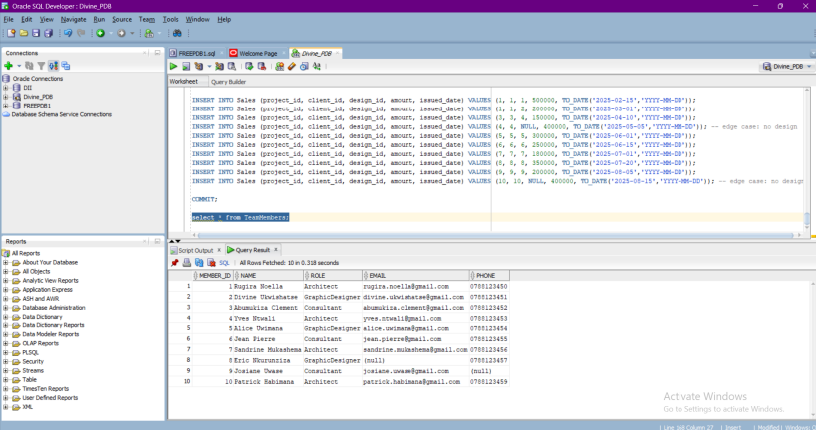
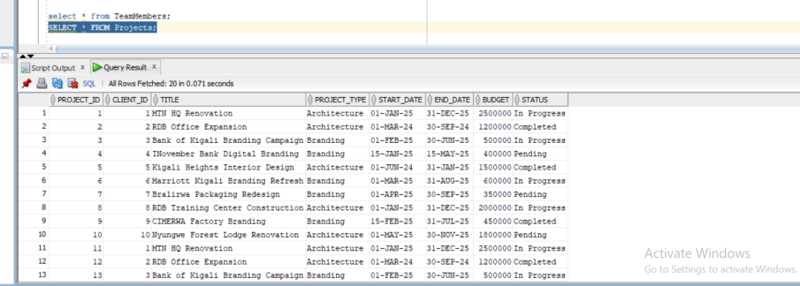

Join queries

SELECT p.project_id, p.title, p.project_type, c.name AS client_name
FROM Projects p
JOIN Clients c ON p.client_id = c.client_id;

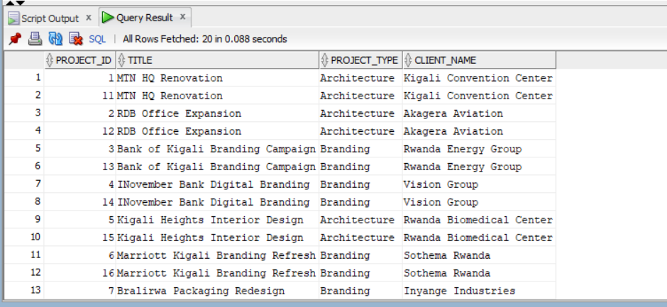

SELECT d.design_id, d.design_type, d.file_path, p.title AS project_title, c.name AS client_name
FROM Designs d
JOIN Projects p ON d.project_id = p.project_id
JOIN Clients c ON p.client_id = c.client_id;

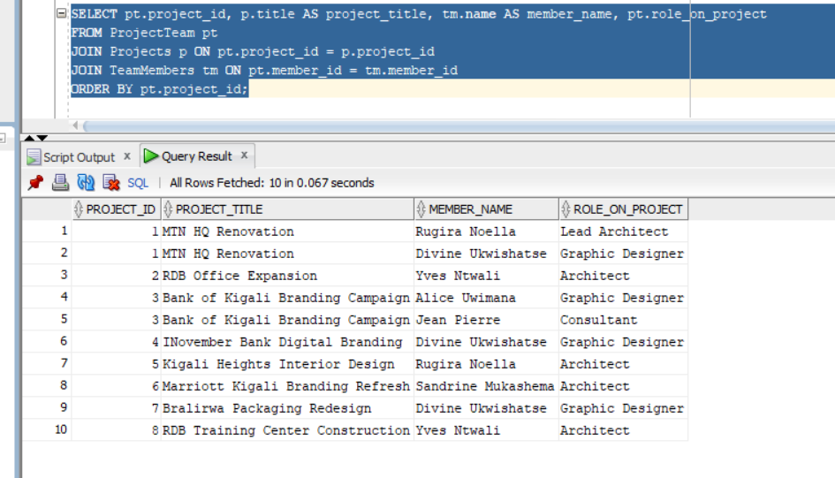

s
Aggregation query

SELECT c.name AS client_name, SUM(p.budget) AS total_budget
FROM Projects p
JOIN Clients c ON p.client_id = c.client_id
GROUP BY c.name
ORDER BY total_budget DESC;

Total budget per client
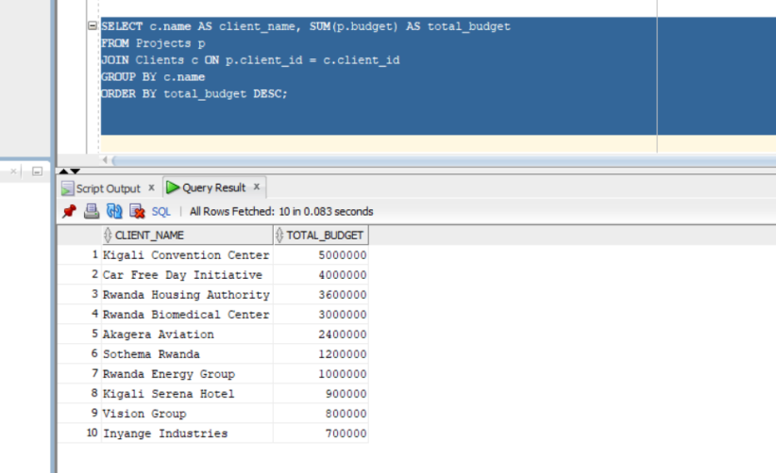

Foreign keys check
